============Text file==================

1. **Creating table**

CREATE TABLE AVIATION(year int, month int, flight_no int, org string, dest string, distance int, cancelled int, cancellation_code string, diverted int, dep_delay string)

row format delimited

fields terminated by ','

stored as textfile;

1. **Load data**
2. **File size:**

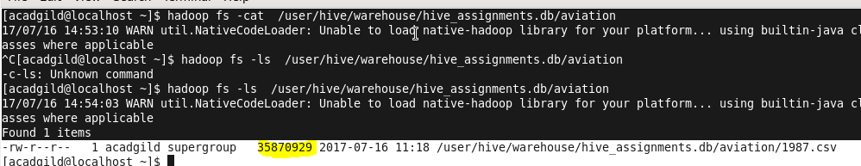

**Original text file size is around 30 MB.**

============RC file With compression ==================

To store with compression we need to set following properties:

Enabling compression provides performance gains in most cases and is supported for RCFile and SequenceFile tables.

For example, to enable Snappy compression, you would specify the following additional settings when loading data through the Hive shell.

SET hive.exec.comprxess.output=true;

SET mapred.max.split.size=256000000;

SET mapred.output.compression.type=BLOCK; -- block compression for sequence file

SET mapred.output.compression.codec=org.apache.hadoop.io.compress.SnappyCodec;

CREATE TABLE AVIATION_RC_COMPRESSION(year int, month int, flight_no int, org string, dest string, distance int, cancelled int, cancellation_code string, diverted int, dep_delay string)

row format delimited

fields terminated by '\t'

stored as rcfile;

Inserting into AVIATION_RC_COMPRESSION :

INSERT OVERWRITE TABLE AVIATION_RC_COMPRESSION

SELECT * FROM AVIATION;

================ORC file=======================

1. **Creating table :**

CREATE TABLE AVIATION_ORC(year int, month int, flight_no int, org string, dest string, distance int, cancelled int, cancellation_code string, diverted int, dep_delay string)

row format delimited

fields terminated by ','

stored as orcfile;

1. **Insert data:**

INSERT OVERWRITE TABLE AVIATION_ORC

SELECT * FROM AVIATION;

1. **File size :**

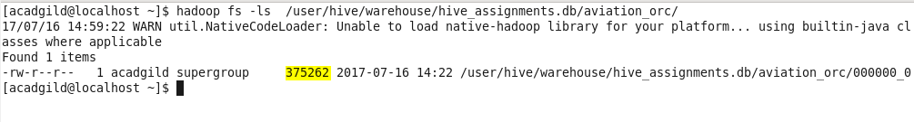

**For ORC file it is just 0.3 MB**